Prototyping process- Libi

The first stage of prototyping we are starting by discussion, with every member of the group involved. We are sharing our opinions and thoughts about how the final product should works, as well as the visual identity of the microsite. Because every single person is unique and has different ideas, all of us sketched our visions and concepts. After that, we are stating one's case and convey the suggestion why we believe our prototype would be a good choice to realize. We agreed and disagreed on some of the decisions, but despite that, all of us approved the prototype we decided to realise.

Due to fact that we decided to start with the mobile-first technique, we are also starting by prototyping for a mobile device, at the first place.

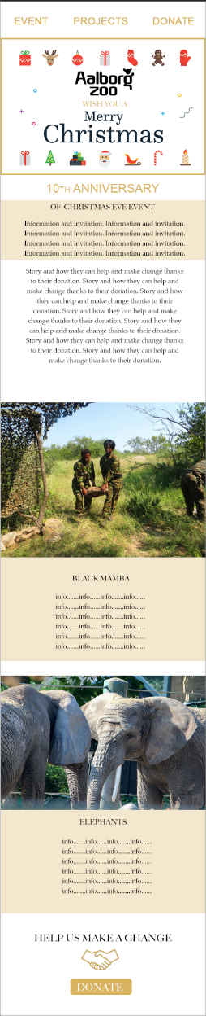In order to assure, all of us are sharing the same ideas for the final visual identity of the microsite, we are deciding to create a photoshop layout based on our previous sketches.

The navigation is placed on the top of the microsite, and by reason of one-page solution, we are choosing to make it fixed on the position while scrolling the website. We are also adding a smooth scroll component to the navigation.

The first element is the image with a Christmas theme to command attention to event closely connected with Aalborg Zoo for 10 years in this time of year. *“Images provide an opportunity to create an emotional connection with visitors — a big, bold photograph or illustration of an object makes a strong statement and creates a stunning first impression. This layout is great when you need to demonstrate only one product/service and focus a user’s attention on it.”* (Tristan, 2018)

In the next section, we are placing a short introduction and invitation to the Christmas Eve event. The content is aimed at users, who are more likely to be interested in this event. In this case is our focus on families and young people.

Underneath the invitation, we are writing about how the event became a tradition, and we are pointing out how this time of year should be focused on helping and carrying. In that way, we are trying to raise awareness with regards to possibilities of donating.

The Projects section consist of the Images and information about each of the currently running projects. We are choosing to use a grid to create this part, which will make the process easier due to fact that we want to make this part to be different on the mobile from the other devices.

On the mobile will be structure, of this section, designed as one column and six rows. The structure of the tablet and desktop version will have two columns and three rows with the *“Alternating layout, which alternates the placement of image and text on each horizontal row. The zigzag layout’s recent popularity is likely due to the fact that it breaks monotony and adds visual interest to a long page.”* (Flaherty, 2018)

The last part of the microsite is aimed at the donation. To address the user, we are using the slogan: "Help us make a change." To emphasize the meaning we are adding the image of shaking hands, which is a sign of helping and supporting. "Using visual communication is crucial to an overall strategic communication plan." (Boatman, 2018)

We are planning to make the Donation button connected to the donation form when the button is active, to maintain the one-site solution.

During this stage, we are deciding not only about the placement of the elements but also about their visual appearance. We are agreeing to keep the look of the website simple and pure. To emphasize the Christmas themes, we are using gold colour on white background, with red details on the top image.

Bibliography:

- Tristan I. (2018). *9 Best Website Layout Examples and Ideas for Web Design in 2018*. [online] Mockplus.com. Available at: https://www.mockplus.com/blog/post/website-layout-example [Accessed 4 Dec. 2018].

- Flaherty, K. (2018). *Zigzag Image–Text Layouts*. [online] Nielsen Norman Group. Available at: https://www.nngroup.com/articles/zigzag-page-layout/ [Accessed 4 Dec. 2018].

- Boatman, A. (2018). *How to Use Visual Communication and Why It Matters*? [online] TechSmith Blog. Available at: https://www.techsmith.com/blog/why-visual-communication-matters/ [Accessed 4 Dec. 2018].